Implementing and using minitwit.

Flask’s github repository contains a cool example of a minitwitter. It is meant to be implemented in linux. The purpose of this post is to implement it in windows.

Steps:

- download the necessary tools
- effect changes to the config file
- run the app

Download the necessary tools
Go to https://git-scm.com/download/win and download the git bash client, install it and clone the project in your hard disk. For that purpose open the Git bash client and type the following commands:
cd c:\\
git clone https://github.com/pallets/flask
(For additional info about git and using it https://www.linkedin.com/pulse/api-test-automation-ci-using-github-jenkins-slack-talal-ibdah )
Once you do that, in your local disk navigate to C:\flask\examples\minitwit.
I copied the folder into my python’s folder:
C:\Python34\minitwit

Or simply click on “Clone or download” and hit “Download ZIP”
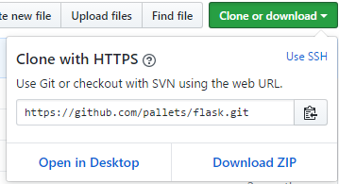
And proceed copying the folder minitwit to the python’s folder as indicated above.

Now install the needed flask libraries:
pip install flask
pip install flask-restful
pip install sqlalchemy

Note: in order to use pip you can download get-pip.py from https://pip.pypa.io/en/stable/installing/#do-i-need-to-install-pip, or use the file from this post. Then run python get-pip.py
Note: notice that pip is also a perl command so use the fully qualified path.

Install sqlite3.exe from https://sqlite.org/download.html, get the sqlite-tools-win32-x86-3180000.zip

Effect changes to the config file
I have modified the instructions in https://github.com/pallets/flask/blob/master/examples/minitwit/README

2.1 edit the configuration in the minitwit.py file: in my case C:\Python34\minitwit\minitwit\minitwit.py
The only change needed there is to convert from the original linux DATABASE=’/tmp/minitwit.db’ to:
DATABASE = 'C:\\Python34\\minitwit\\minitwit\\tmp\\minitwit.db'
2.2 install the app from the root of the project directory

pip install --editable .

2.3. tell flask about the right application:

in this case change: export FLASK_APP=minitwit, needs to be changed to
set FLASK_APP=minitwit

2.4. fire up a shell and run this:

Instead of flask initdb use python –m flask initdb. The database will be created in the folder you specified.

3. Now you can run minitwit:

Set the FLASK_APP=minitwit and change flask run with python –m flask run, as indicated below:
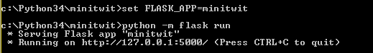
  - in the browser, type localhost:5000, you are greeted with:
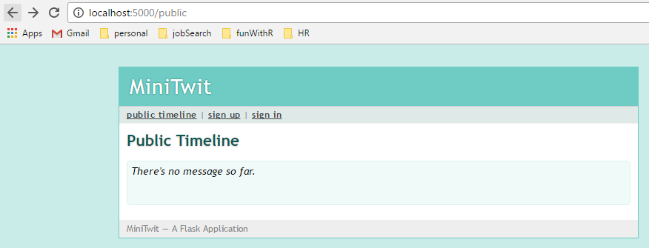
  - at that point sign up and then sign in:

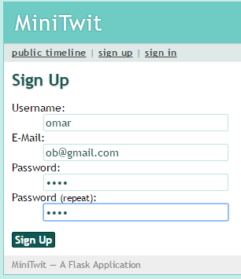
And start posting there:
